Lab 10: Anti Reversing Techniques

CYBR 688: Software Reverse Engineering

Team Members: Sairam Bokka, Ethan Hart

Introduction:
The goal of this lab is to learn about and apply anti-reversing methods to a program that executes a sensitive key-checking algorithm. This lab will cover a brief analysis of the algorithm used in the program and the implementation of two anti-reversing techniques applied to the program to protect the sensitivity of the algorithm. One technique will aid in preventing static analysis, while another technique will attempt to prevent dynamic analysis.

Materials:
-Licensed copy of Linux (Ubuntu 24.04.1 Virtual Machine used for this lab).
-Supplied lab files from Blackboard, which includes the license key checker.

Procedure

Key-Checking Algorithm Overview
- Program Flow:
- The program takes two command-line arguments: username and key
- The key must be 32 characters long, representing 16 bytes in hexadecimal format
- The program processes the username through a SHA1 hash and performs a comparison with the key
- Key Validation Process:
- The doCheckConvert function:
  - Verifies the key is exactly 32 characters long
  - Converts the hex string key into 16 bytes
  - Passes these to doCheck
- Core Algorithm (doCheck):
- Takes the username and generates its SHA1 hash using OpenSSL
- Performs two calculations:
  - checkSHA1: Takes the SHA1 hash bytes and reduces them to a 16-bit value by:
    - Multiplying by 31 and adding each byte of the SHA1 hash
    - After calculation, the value is XORed with constant 0x5A3C
  - checkKey: Takes the provided key bytes and reduces them to a 16-bit value by:
    - Multiplying by 127 and adding each byte of the key
  - The key is valid if these two 16-bit values match
- Debug Mode Features:
- In debug builds (_DEBUG), there's a key generator that:
  - Takes just a username as input
  - Generates random keys and tests them
  - Continues until it finds a working key
  - Uses a simple increment strategy to try different keys

Static Analysis Prevention
- Adding Junk Code:

- One way that we implemented static analysis prevention in our program was by adding junk functions and variables that seem to be performing tasks pertinent to the key-checking algorithm.
- These added variables invite attention from a user performing static analysis due to their intriguing names, such as doHash(), validateHash(), unsigned long staticHash, and others.
- In addition to these functions being scattered randomly throughout the source code with no pattern, they are also nested within the program’s original functions and call each other in a manner that adds superfluous stack calls.
- These fake functions also take in the same parameters for input as the original program functions do, which hopefully provides a convincing argument to a reverse engineer that these functions are pertinent to the program’s operations.
- Furthermore, the resulting logic of some of these fake functions is implemented into the original functions used in the key-checking algorithm while preserving the functionality of the program.
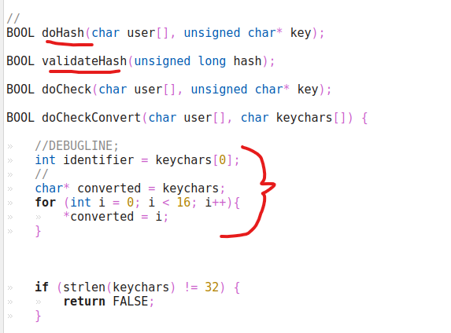
Code underlined or sectioned with red is injected code that adds confusion
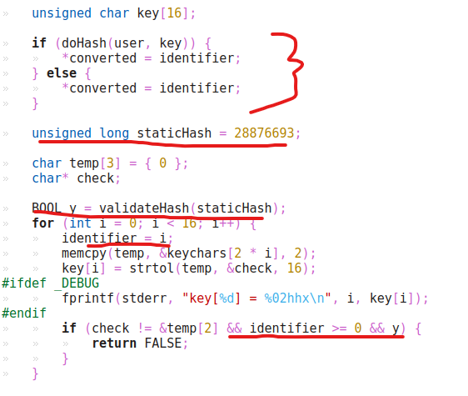
Injected logic, variables, and bogus function calls in red

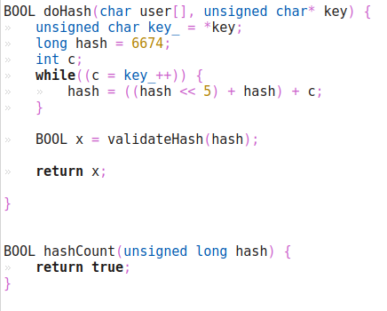
Example definitions for bogus functions.

Dynamic Analysis Prevention
- Anti-debugger Techniques using ptrace:

- To successfully obfuscate our code against dynamic analysis, we must embed an anti-debugger mechanism within our program.
- Since there are many debuggers and platforms that we could develop a mechanism for, we chose to implement countermeasures for the gdb debugger on Linux. This widely known C debugger is the primary debugger used on the main OS for this course.
- The mechanism implemented in this lab revolves around the ptrace() system call in Linux. The ptrace() system call is leveraged by debuggers such as gdb and strace, allowing one process (the tracer) to take control of another (the tracee).
- One feature of ptrace() on Linux is that a tracee can only be controlled by a single tracer at a time. If another program attempts to be the tracer of that same tracee, that program’s control request will be blocked. If gdb is launched with our executable, the executable becomes the tracee of a ptrace() system call executed by gdb.
- In our executable, we can make a call to ptrace() with the requested tracee process being the executable itself. When it returns with a failure code, the executable crashes and returns an ambiguous error message to point the user toward fixing the program’s input parameters.

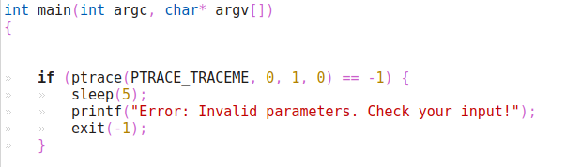
Executable source code calls ptrace() on itself to see if a debugger is attached.

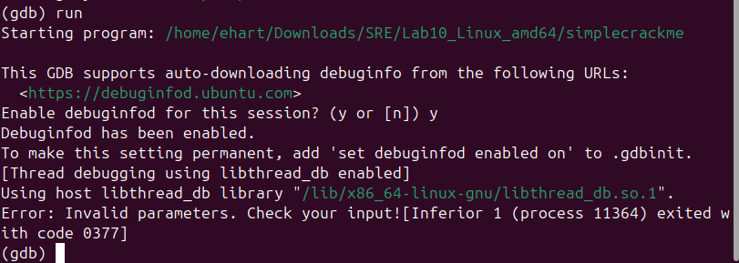
An unsuccessful attempt to debug the executable through gdb on Linux.

Conclusion
In this lab, we were able to implement separate techniques to combat the potential reverse engineering of the key-checking algorithm. To resist static analysis, we injected variables, logic, and functions into the source code that maintain the code’s functionality while adding confusion and additional research to slow a reverse engineer. For resisting dynamic analysis, we implemented logic to check for an active debugger by using the ptrace() system call on Linux, which checks to see if our program is currently being controlled by a separate process.

